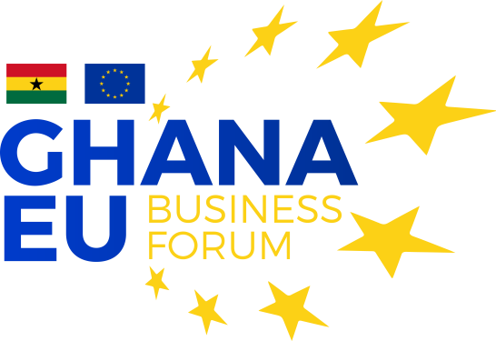
"Boosting investments for sustainable jobs in Ghana"

13 and 14 June 2019
Movenpick Hotel

Draft programme
Day 1 – 13 June 2019
08.00 09.00 | Registration of the participants
Opening Session
09.00 10.00 | Welcome by the EU Ambassador to Ghana |  | EU Delegation to Ghana
 | Ghana Beyond Aid |  | Ministry of Finance
 | The EU-Africa Alliance |  | European Commission, DG DEVCO
Session 1 – Economic transformation and opportunities for investors in the framework of the Ghana beyond Aid context
10.00 11.30 | Ghana economic transformation |  | Ministry of Industry
 | The challenges on the monetary policy and markets development in Ghana |  | Bank of Ghana
 | What investment opportunities for Ghana? |  | Ghana Investment Promotion Centre (GIPC)
 | Q and A session |  | Participants
11.30 12.00 | Networking coffee break
Session 2 – Opportunities offered by the EU: Innovative financing for boosting investments and jobs creation - the External Investment Plan (EIP)
12.00 13.00 | What is and how the EIP works, identified priority sectors, timeline |  | European Commission, DG DEVCO
 | Harnessing access to EU market to leverage foreign investments |  | Eurpean Commission, DG TRADE
 | Q and A session |  | Participants
13.00 14.00 | Lunch break
Session 3 - Roundtable discussion with public interaction
14.00 15.30 | Business climate in Ghana: what has been done and what should still be done to facilitate doing business in Ghana? |  | Moderator: European Commission, DG TRADE  Ministry of Finance  Bank of Ghana  Oasis Capital Ghana ltd  European Business Organisation (EBO)  Association of Ghana Industries (AGI)
15.30 16.00 | Networking coffee break
Session 4 – Financial support to Investment Opportunities
 | AFD Group - Proparco | KfW
16.00  17.30 | Sustainable agriculture, rural entrepreneurship and agroindustry; sustainable energy and connectivity; micro, MSMEs financing | Sustainable energy and connectivity |  | Interactive sessions with companies operating or interested to invest in the sector and the Financing Institutions managing the investment tools &/or guarantee schemes
17.30 | Closure of the day

Day 2 – 14 June 2019
Session 5 – Financial support to Investment Opportunities
 | ElectriFI | AfDB
09.30  11.00 | Sustainable energy and energy efficiency | Sustainable agriculture, rural entrepreneurship and agroindustry |  | Interactive sessions with companies operating or interested to invest in the sector and the Financing Institutions managing the investment tools &/or guarantee schemes
11.00 11.30 | Networking coffee break
Session 6 – Financial support to Investment Opportunities
 | FMO | EIB
11.30  13.00 | Sustainable agriculture, rural entrepreneurship and agroindustry; micro, MSMEs financing | Sustainable energy and connectivity; micro, MSMEs financing |  | Interactive sessions with companies operating or interested to invest in the sector and the Financing Institutions managing the investment tools &/or guarantee schemes
13.00 14.00 | Lunch break
Session 7 - Roundtable discussion with public interaction
14.00 15.00 | The way forward: establishing priorities for the political, institutional, regulatory, and operational frameworks. |  | Moderator: Evans Mensah  African Center for Economic Transformation (ACET)  Local commercial bank  European Commission, DG DEVCO
Closing Session
15.00 15.30 | Closing remarks by Jyrki Katainen, Vice President, European Commission, and by high representative of Government of Ghana

